Part 3 | Please use BLOCK CAPITALS when completing the form  * Mandatory information

Your Child’s legal name*

- CHILDCARE PROVIDER DETAILS

[A] Childcare Provider Name*

You must state if the funded entitlement will be split between provider’s (maximum of two providers in a single day). This will also ensure the funding is paid fairly. Your providers should discuss and work closely with you to agree how your child’s overall childcare will work in practice to ensure a smooth transition.

Is your funding entitlement shared with (an)other provider(s)*? YES / NO
If YES*, my child is also attending – | Funded Hours Claimed
[B]
[C]

- CHILDCARE CONTRACT / ARRANGEMENT (pattern of attendance)

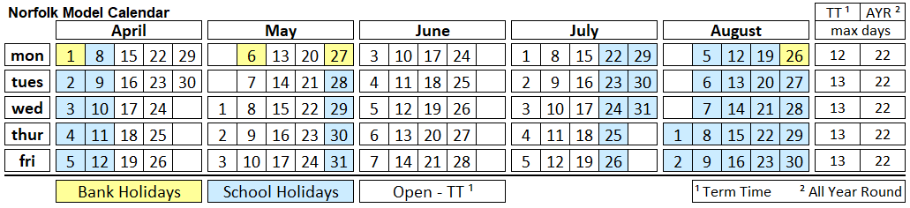

My child is booked to attend*: | Mon | Tue | Wed | Thu | Fri
 | Use the calendar to count how many of each day your child will attend as agreed with your provider (for example: 12 Mondays)
How many weekdays* (A) |  |  |  |  |  |  | Total
How many hours each day* (B)
Total Hours* (A x B)

- FUNDING FOR SUMMER CLAIM PERIOD

Start Date* | End Date* | Funding should be claimed
TERM TIME
ALL YEAR ROUND (stretched)

Based on your childcare arrangement, your provider will confirm the –
- number of weekly funded hours that can be claimed
- maximum total funded hours available for the claim period
Weekly Funded Hours* | Total Funded Hours*

Please be aware you may need to pay for additional hours where there are not enough funded hours to cover your childcare arrangement. Check with your provider before signing this claim form.

If the entitlement is shared with other providers, the total of the combined claims cannot exceed the total funded hours available for the claim period and funding rules must be met.

- DECLARATION

I understand that:

- I am responsible for ensuring that my child attends the patten of attendance for funding purposes (Part 3 section 2) and I can request via my childcare provider a change to the number of funded hours claimed up to the maximum available

- the claim must adhere to the rules of funding, and it is fraudulent to sign up to or claim more funded hours than my child is attending

- hours not funded by the Local Authority (LA) are additional hours and fees will apply in accordance with my childcare provider’s charging policy

- my provider can charge fees within the rules of funding, and if I am unable to pay, I can discuss this with them

- if I fail to provide complete and accurate information, this will affect my funding claim and fees may apply

- except where there are safety or quality concerns for which a formal complaint has been made to Ofsted and substantiated, if I decide to end my child’s childcare arrangement without giving the required notice period, it will affect my next funding claim at my new provider

- if I have any concerns regarding my child’s funded place, I will attempt to resolve this with my childcare provider in the first instance, however, if my concerns cannot be resolved, I can contact the LA’s funding team

- the personal information that I provided will be held, and used –
  - in compliance with the General Data Protection Regulation
  - to contact me about my funding claim if needed
  - for analysis and statistical purposes including government returns
  - to support my child’s learning and development

- my personal information will not be shared to a third party

- if my family is identified as eligible for Early Years Pupil Premium (EYPP) and or Disability Access Fund (DAF), the extra funding will be paid to my childcare provider(s) until my child is no longer accessing a funded entitlement or I need to re-confirm eligibility

- extra funding details will be shared with all my childcare provider(s)

- the parent/carer claim form will be requested by the LA to resolve disputes, check claims, investigate fraudulent claims and for audit purposes

I confirm:

I have read the information provided in Part 1 and Part 3 Section 4 of the parent/carer claim form

My information can be used as detailed in Part1 and Part 2 of the parent/carer claim form

I will communicate with my provider if my childcare arrangement, eligibility, or details change, or I have any concerns

I am the parent/carer with legal responsibility for the child named in Part 2

The information I have provided is accurate and true. I understand and agree to the conditions set out in the parent/carer form and I authorise my childcare provider [A] named in Section 1 to claim the funded entitlement on my behalf for my child.
Parent / Carer* |  | Childcare Provider*
Signed: |  | Signed:
Print name: |  | Print name:
Date: |  | Date:

In collecting your data for the purposes of checking your eligibility for the funded entitlements, EYPP or DAF, Norfolk County Council is exercising the function of a government department.

Norfolk County Council is authorised to collect this data pursuant to Section 13 of the Childcare Act 2006.

